Integrating Zoho Creator with Zoho CRM via Connections and APIs

Aim
To design, develop, and integrate a custom job Application form in Zoho Creator with Zoho CRM using authenticated connections and automated workflow actions, enabling seamless lead generation and data synchronization upon successful form submission.

Procedure

  - Application Setup: Log into the Zoho Creator platform and create a new application titled
Bank Loan Application.
  - Form Design: Construct the job_Application_Form incorporating Section-A (Personal details: Applicant Name, Date of Birth, PAN Number), Section-B (Contact details: Email, Phone, Address), and Section-C (Income and employment details).
  - Integration & Authentication: Navigate to App Preferences > Manage Integrations. Select Zoho CRM and establish a secure OAuth connection. Verify that the connection badge displays Connected.
  - Workflow Configuration: Go to the Workflow tab, select the Loan Application Form, and create a new workflow under the trigger event Created > Successful form submission.

  - Action Mapping: Add an integration action inside the execution block to push applicant data directly to Zoho CRM modules, then toggle the workflow status to Enabled.

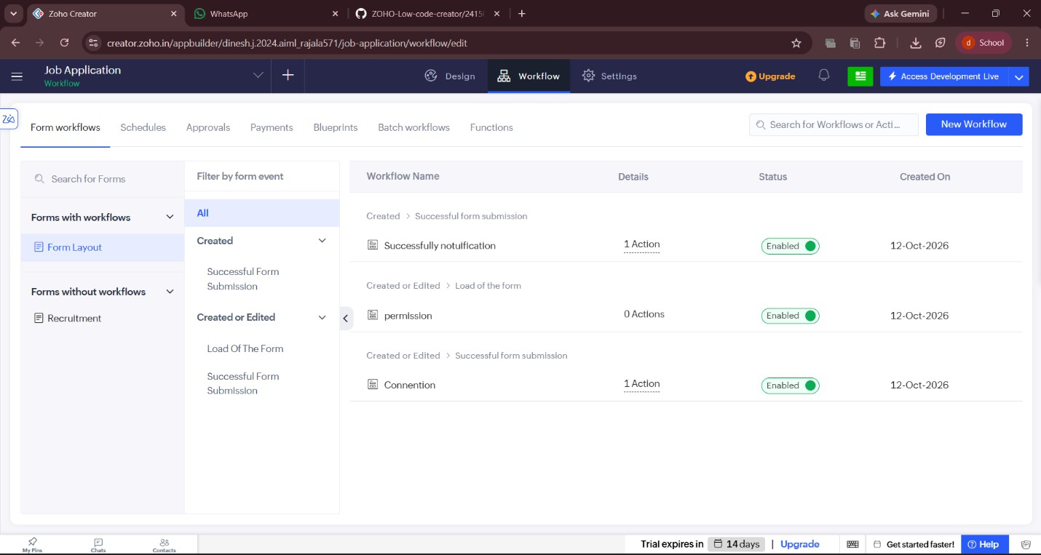
Screenshots:

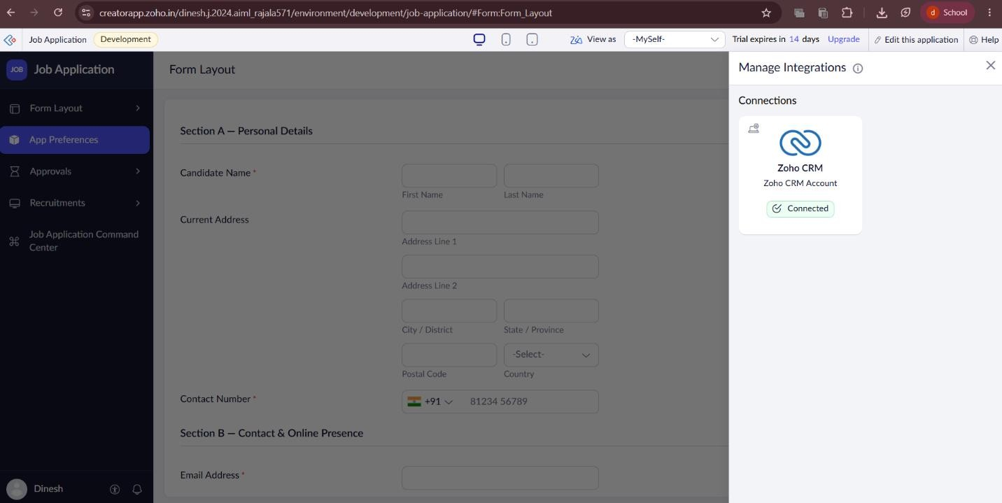

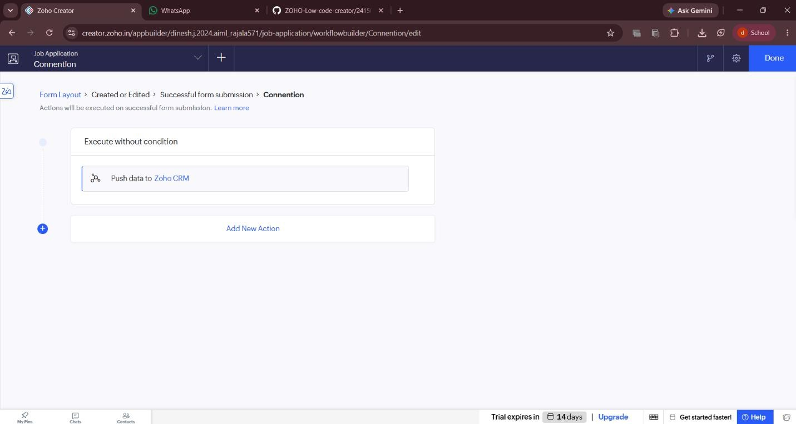

Result
The job Application was successfully created and integrated with Zoho CRM. Whenever an applicant fills out and submits the loan form in Zoho Creator, the workflow triggers automatically, successfully executing the API push action to synchronize applicant details into Zoho CRM in real time.

